DAY- 29 (21/8/2025)
Emp ID : 110714877
NAME :Kinnera venkatamma

NO-SQL & CLI Installation done

Task 1:

Create a data model -ATLAS Batch1
Add a table - MyBatch
Attributes - id, Empid, f name, l name, city, ph no

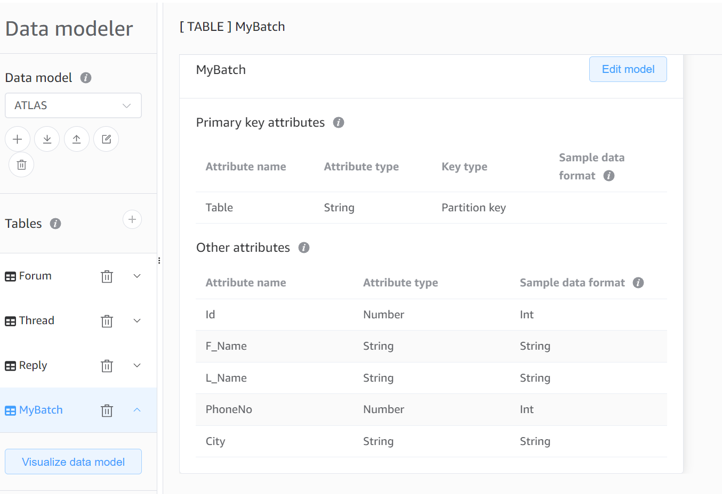

Create table.java

import java.util.Arrays;
import com.amazonaws.services.dynamodbv2.AmazonDynamoDBClient;
import com.amazonaws.services.dynamodbv2.document.DynamoDB;
import com.amazonaws.services.dynamodbv2.document.Table;
import com.amazonaws.services.dynamodbv2.model.AttributeDefinition;
import com.amazonaws.services.dynamodbv2.model.KeySchemaElement;
import com.amazonaws.services.dynamodbv2.model.KeyType;
// throughput
import com.amazonaws.services.dynamodbv2.model.ScalarAttributeType;

public class Createtable {
public static void main(String[] args) throws Exception {
AmazonDynamoDBClient client = new AmazonDynamoDBClient().withEndpoint("http://localhost:8000");
DynamoDB dynamoDB = new DynamoDB(client);
String tableName = "Empoloyee";

try{
Table table = dynamoDB.createTable(tableName, Arrays.asList(new KeySchemaElement("ID", KeyType.HASH), ))
}

}
}

Or same as above.. But below is complete..

import java.util.Arrays;
import com.amazonaws.services.dynamodbv2.AmazonDynamoDBClient;
import com.amazonaws.services.dynamodbv2.document.DynamoDB;
import com.amazonaws.services.dynamodbv2.document.Table;
import com.amazonaws.services.dynamodbv2.model.AttributeDefinition;
import com.amazonaws.services.dynamodbv2.model.KeySchemaElement;
import com.amazonaws.services.dynamodbv2.model.KeyType;
// throughput
import com.amazonaws.services.dynamodbv2.model.ProvisionedThroughput;
import com.amazonaws.services.dynamodbv2.model.ScalarAttributeType;

public class Createtable {
public static void main(String[] args) throws Exception {
AmazonDynamoDBClient client = new AmazonDynamoDBClient().withEndpoint("http://localhost:8000");
DynamoDB dynamoDB = new DynamoDB(client);
String tableName = "Empoloyee";

try{
Table table = dynamoDB.createTable(tableName, Arrays.asList(new KeySchemaElement("ID", KeyType.HASH),
new KeySchemaElement("no", KeyType.Range)
),
Array.asList(new AttributeDefinition("ID", ScalarAttributeType.N),
new AttributeDefinition("no", ScalarAttributeType.S)
),
new ProvisionedThroughput(5L,5L)
);

table.waitForActive();
System.out.println(" table description "+ table.getDescription().getTableStatus());
}catch (Exception ex) {
Susyem.out.println("error "+ ex.getmessage());
}

}
}

Table loading data.java

package com.example;

import java.io.File;
import com.amazonaws.services.dynamodbv2.AmazonDynamoDBClient;
import com.amazonaws.services.dynamodbv2.document.DynamoDB;
import com.amazonaws.services.dynamodbv2.document.Table;
import com.amazonaws.services.dynamodbv2.document.Item;
import com.fasterxml.jackson.JsonFactory; // core.JsonFactory;
import com.fasterxml.jackson.core.JsonParser;
import com.fasterxml.jackson.atabind.JsonNode;
import com.fasterxml.jackson.databind.ObjectMapper;
import com.fasterxml.jackson.databind.node.ObjectNode;

public class EmployeeLoadingData {
public static void main(String[] args) throws Exception {
AmazonDynamoDBClient client = new AmazonDynamoDBClient().withEndpoint("http://localhost:8000");
DynamoDB dynmoDB = new DynamoDB(client);
Table table = dynamoDB.getTable("Employee");
JsonParser parser = new JsonFactory().createParser(new File(Table.json));
JsonNode rootNode = new ObjectMapper().readTree(parser);
Iterator<JsonNode> iterate = rootNode.iterator();
while (iterate.hasNext()) {
currentNode = (ObjectNode) iterate.next();
int ID = currentNode.path("ID").asInt();
String NomenClature = currentNode.path("NomenClature").asText();

try{
table.putItem(new Item().withPrimarykey("ID", ID, "NomenClature", NomenClature));

System.err.println("wow add item in employee table is successful "+ ID + " "+ NomenClature);

}catch(Exception ex) {
System.err.println("sorry cant add item in employee table "+ ID + " "+ NomenClature);
System.err.println(ex.getMessage());
break;
}
}
parser.close();
}
}

Table.json

[
{
"ID" : 1001,
"NomenClature" : "ABC 1001",
"Name" : "Prasunamba"
},
{
"ID" : 1002,
"NomenClature" : "XYZ 1002",
"Name" : "Meher"
},
{
"ID" : 1003,
"NomenClature" : "SSS 1002",
"Name" : "K"
}
]

